Robin Hood: Alternative Ending

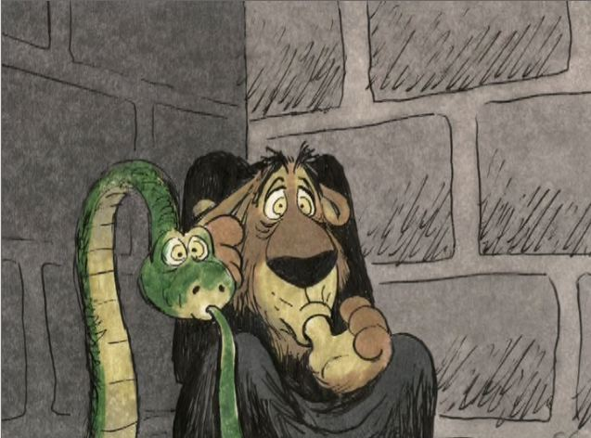
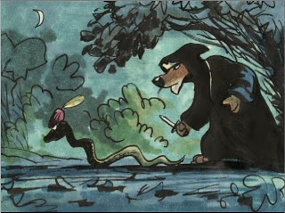
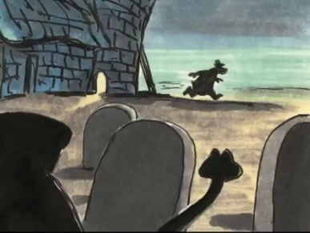
This is the alternative ending of the film “Disney’s Robin Hood”. In this version of the ending Robin Hood is wounded by the arrows that shooting him while he’s escaping from the castle. As Prince John and his soldiers head out to chase him Robin gets rescued by Little John who takes him to the church. Meanwhile Sir Hiss spot the drops of blood that left by Robin and then he and Prince John follow the trail to the church. Seeing Little John leaving he thinks that Robin Hood is there and alone. Entering to the church shoes Maid Marian who treating Robin’s wounds. He offers "put Robin out of his misery" while taking a dagger out of cloak. Maid Marian bravely tells him to not come any closer and that he isn’t the king to which Prince John retorts that nobody gives orders to "King John”. Suddenly King Richard enters and shows Prince John and says "Well, Brother John, up to your old tricks I see”. Prince John was leaving the people oppressed so that makes their mother upset. Later King Richard returns the city of Nottingham to his rightful glory and he knight Robin as "Sir Robin of Locksley” also orders Friar Tuck to merry Robin and Marian (which done soon). The reason that they didn’t make that ending in the movie is that this ending was too dark and strong for younger children but it also appears as deleted scene in the DVD version.
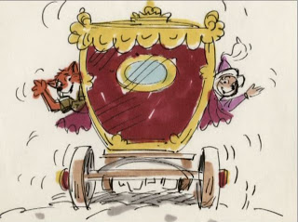
But like the most Disney movies we have Happy End.

