DÉJÀ VU
Maybe some of you have noticed that some Disney films have the “moves”. For example in the movie “Disney’s Robin Hood” during the song “The Phony King of England” it seems that something is familiar with the moves. That is because with budgets tight during this stage of transition, animation for Disney’s Robin Hood quite literally had “to rob” from the riches of the studio’s previous successes: most notably The Jungle Book, The Aristocats and Snow White and the Seven Dwarfs…
Here are some examples:
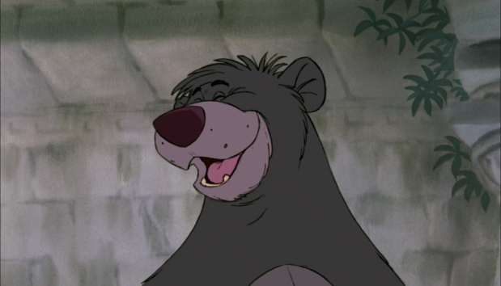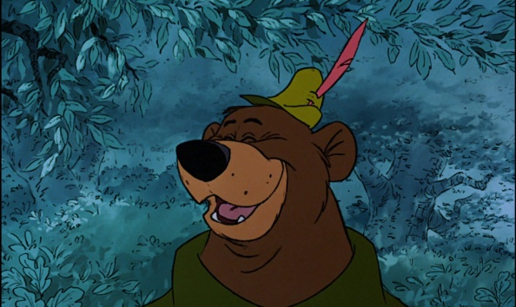
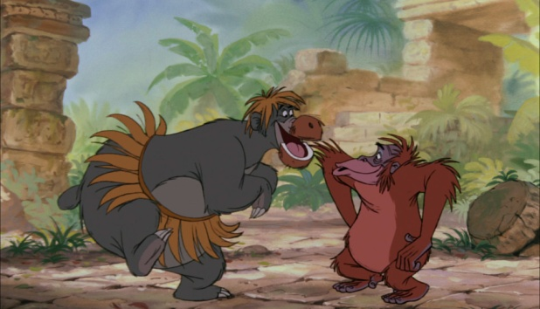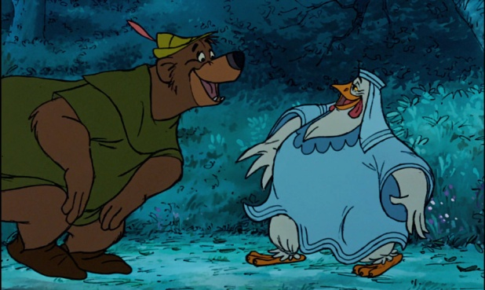
So Baloo and Little John have many similarities as both are bears but also they voiced by the same actor (Phill Harris)
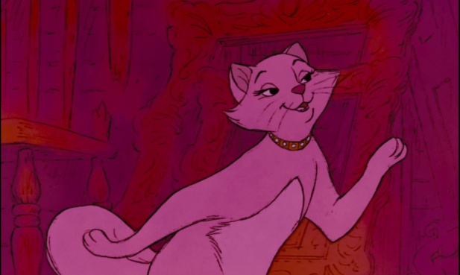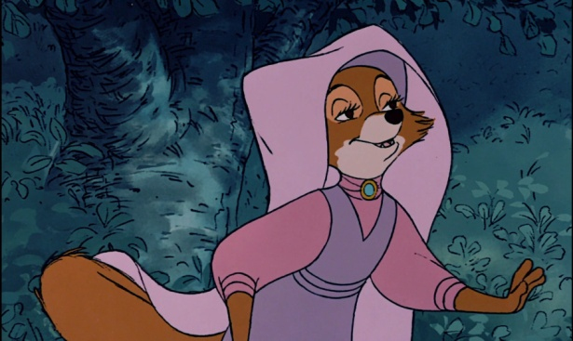
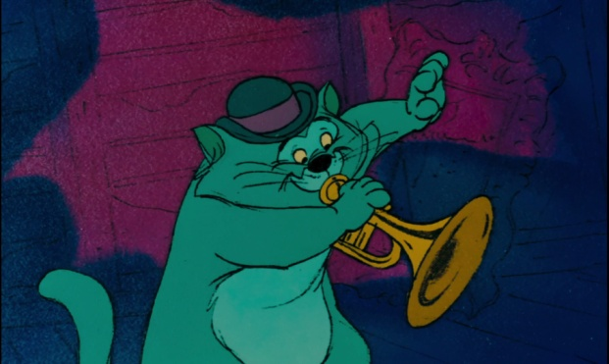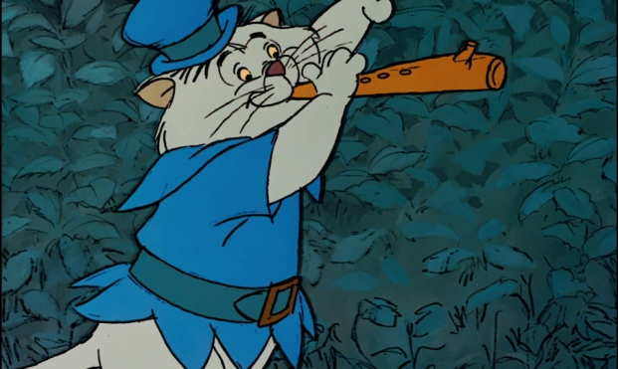
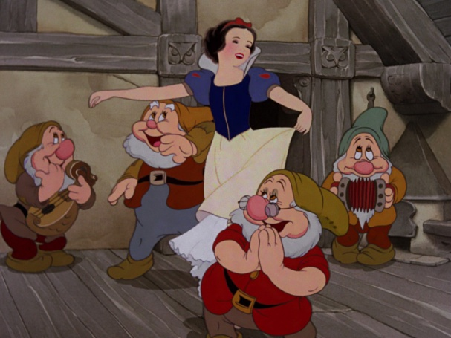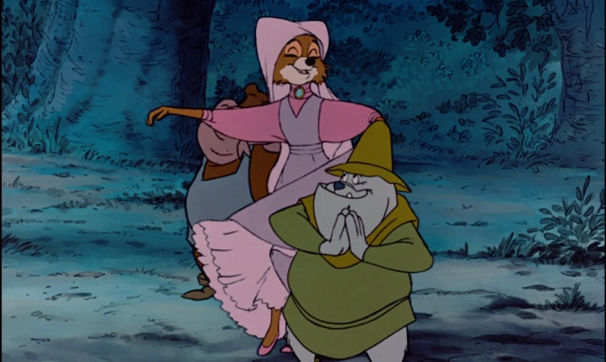
Snow White. I remember when I first show it on VHS it’s an old movie but Disney’s first animated film.
Well maybe all these” recycling” has to do with the low budgets but Robin Hood in not the only film that used “moves” from other films . There are other films such as “Sword in Stone”, ”The Many Adventures of Winnie the pooh” etc .(find more here: https://www.youtube.com/watch?v=jYqqR7efUdY )
But doesn’t means that these films aren’t good . Disney wanted just to save money since Walt’s death

