Hotel Blasts ‘Circle of Life’ from ‘Lion King’ to Wake Up Spring Breakers
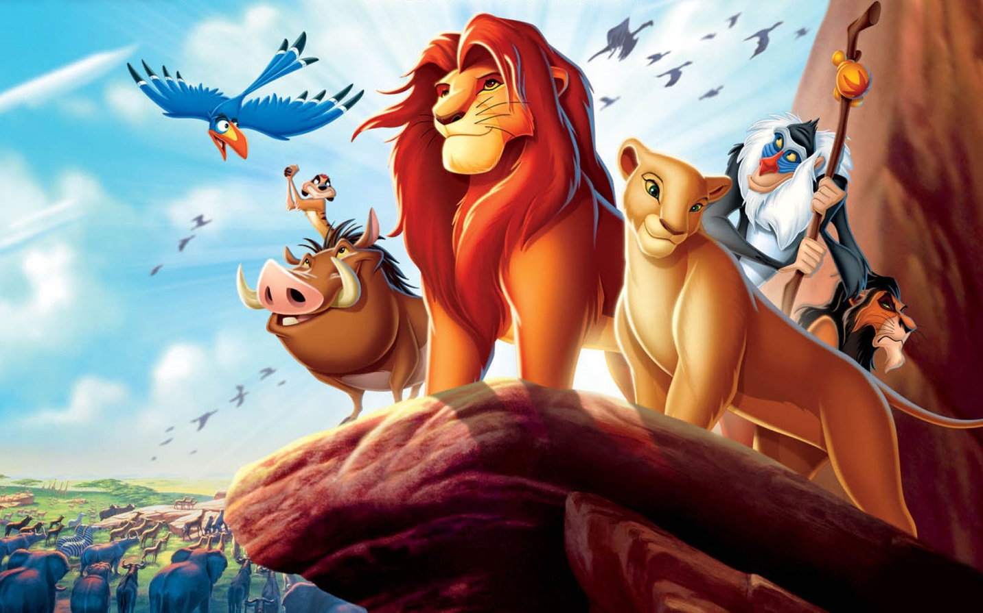

Waking up with a hangover after a night of partying? No way. Waking up with a hangover after a night of partying to the sounds of The Lion King’s inspirational “Circle of Life” anthem? So much better.
Panama City Beach Holiday Inn stumbled on a perfect idea a few years back: During Spring Break, the hotel blasts “Circle of Life” every morning at 11:00 a.m. over the loudspeaker – and now it’s become a tradition, with guests gathering on the balconies to listen. This week, the hotel put up a video to this daily event, and it has quickly gone viral. The only disappointment? No one planned ahead and brought a stuffed animal lion to raise to the sky.

I just edited this on Easter, because I found it on Easter… and wow, I really never expected to see much new stuff of TLK, but there is a lot of things people do related to The Lion King, which surprised me. Anyway, here goes:
Ra-peep-ki

Disney’s international mega hit, The Lion King is Broadway’s most lucrative production to date and a brand new social media image celebrating the Easter season is now available to view.
The official Facebook page posted a mock-up photo of an adorable Rafiki version of the popular Easter candy Peeps earlier today, writing, “Rafiki + Peeps = Ra-peep-ki”.
The official description of The Lion King on Broadway is as follows: “In its 18th year, The Lion King remains ascendant as one of the most popular stage musicals in the world. Since it’s Broadway premier one November 13th, 1997, 22 global productions have been seen by more than 75 million people and, cumulatively, ran a staggering 112 years. Produced by Disney Theatrical Productions (under the direction of Thomas Schumacher) The Lion King is only the second show in history to generate five productions worldwide running over ten or more years. Translated into seven different languages (Japanese, German, Korean, French, Dutch, Spanish and Portuguese), productions of The Lion King can currently be seen on Broadway; London's West End; Hamburg; Tokyo; Madrid; Melbourne, Australia; Basel, Switzerland; and on tour across North America and Japan, for a total of nine productions running concurrently across the globe. Having played 20 countries on every continent except Antarctica,The Lion King’s worldwide gross exceeds that of any film, Broadway show or other entertainment title in box office history.
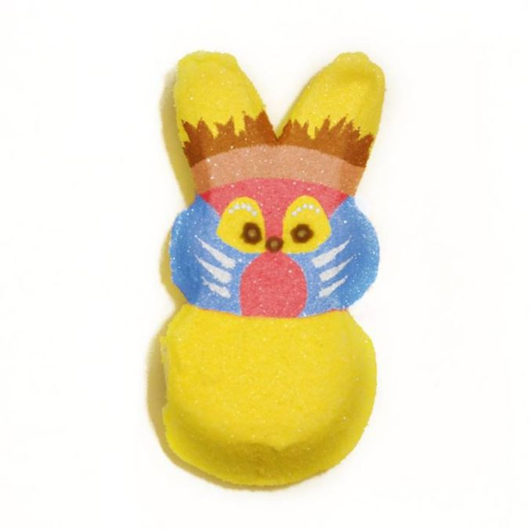
Rafiki Peep

