Alpha and Omega
When Kate, an important take-charge “Alpha” wolf, and Humphrey, a fun “Omega” wolf, get snatched by park rangers, they are relocated to Idaho! The two make an incredible journey back home. With the help of a golf-playing goose, and his duck friend, Kate and Humphrey won’t let anything stop them- porcupines, bears, even a speeding locomotive- from getting back to Jasper Park. Especially since Kate has to save her pack from rivals. Kate and Humphrey learn a lesson, even though there complete opposites, they make a very good team.
Made in: 2010
Characters:
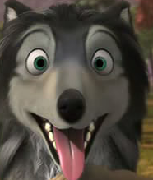 Humphrey is a fun and classic Omega. He’s known as the best one, too. He is in love with a beautiful Alpha, Kate. Only problem: He’s an Omega, she’s an Alpha. And Alpha And Omegas can’t be together. But then, after they get relocated to Idaho, and have a big journey together, they both realize that they make a good team.
Voice Actor: Justin Long
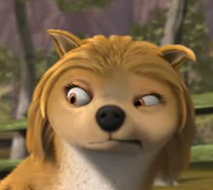 Kate is an important take-charge Alpha. Who is soon to be the leader of a pack? But, she soon finds out that she is going to get married to a charming Alpha from another pack, named Garth. But, when she ran an Omega wolf, named Humphrey, get relocated to Idaho, they must make a journey back home. But on their way back home to Jasper Park, they realize they make a good team.
Voice Actor: Hayden Panettiere
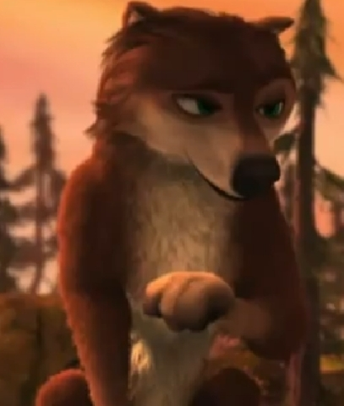 Garth is an Alpha from the Westward Pack. His father is Tony, whom wants him to marry Kate, one of Winston’s daughters. But, when Kate and Humphrey suddenly disappear, Garth starts to fall in love with Lily.
Voice Actor: Chris Carmack
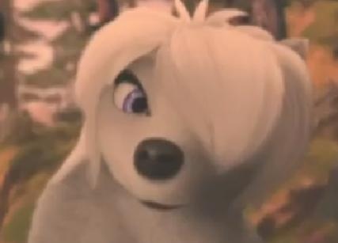 Lily is a funny Omega, whom is one of Winston’s daughters and Kate’s sister. Lily later meets Garth, and shows him around. And it turns out that they both fall in love with each other.
Christina Ricci
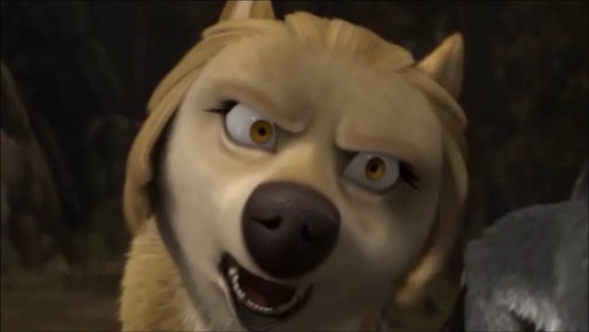 Eve is the mother of Kate and Lily. And who ever hurts her mate, Winston or one of her daughters she says she’ll tear up your throat! She is an Alpha and tries her best to keep the pack safe.
Voice Actor: Vicki Lewis
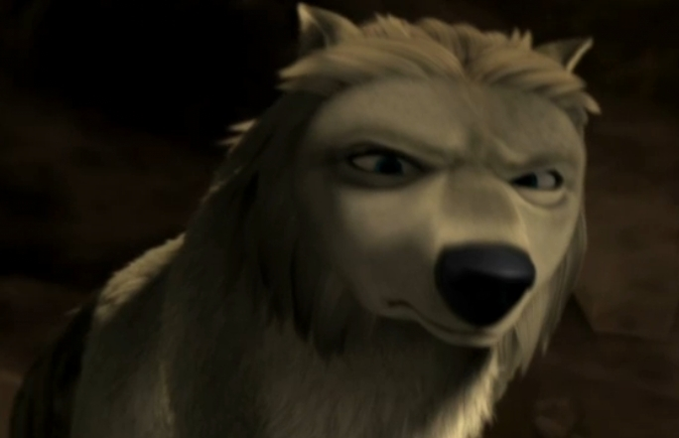 Winston is the father of Kate and Lily and Eve’s mate. He had once made a promise with Tony, the Westward Pack leader, for his son, Garth, for Kate to marry him and to reunite the packs.
Voice Actor: Danny Glover
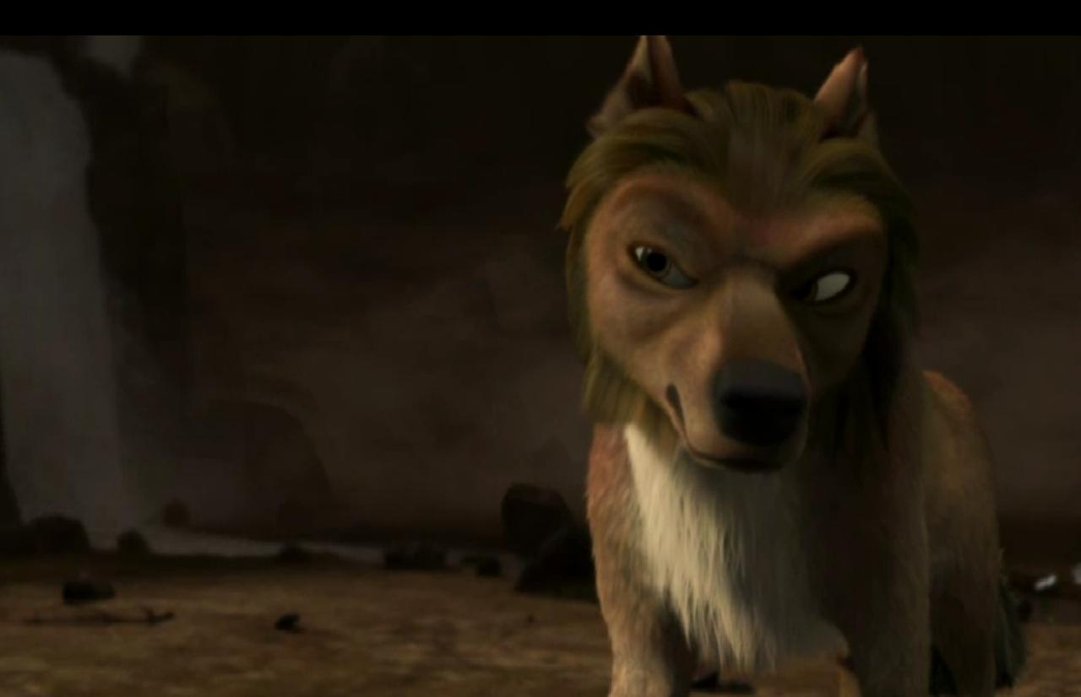 Tony is the leader of the Westward Pack. Tony wants his son Garth, and Winston’s daughter Kate, to get married and reunite the pack. And, when it turned out that Kate fell in love with Humphrey, and Garth fell in love with lily, Tony tried to take the valley.
Voice Actor: Dennis Hopper
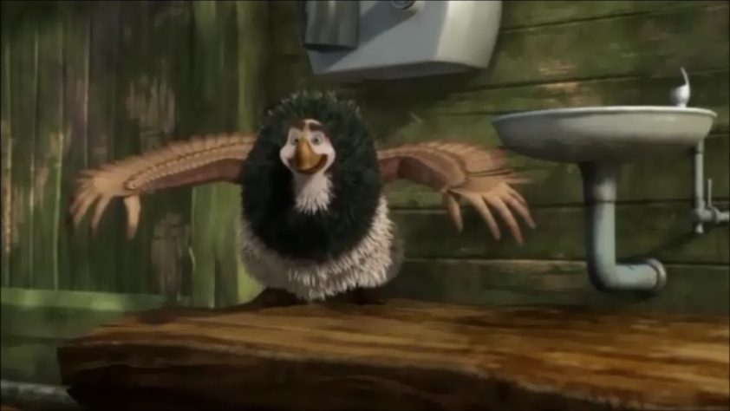 Marcel is a goose that helped Kate and Humphrey get back home to Jasper Park. And, he likes to play golf.
Voice Actor: Larry Miller
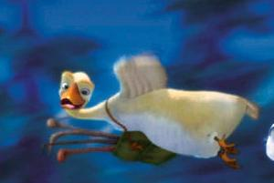 Paddy is a duck that helped Kate and Humphrey back to Jasper Park. His friend is Marcel, whom is a goose that also helped Kate and Humphrey back to Jasper Park.
Voice Actor: Eric Price
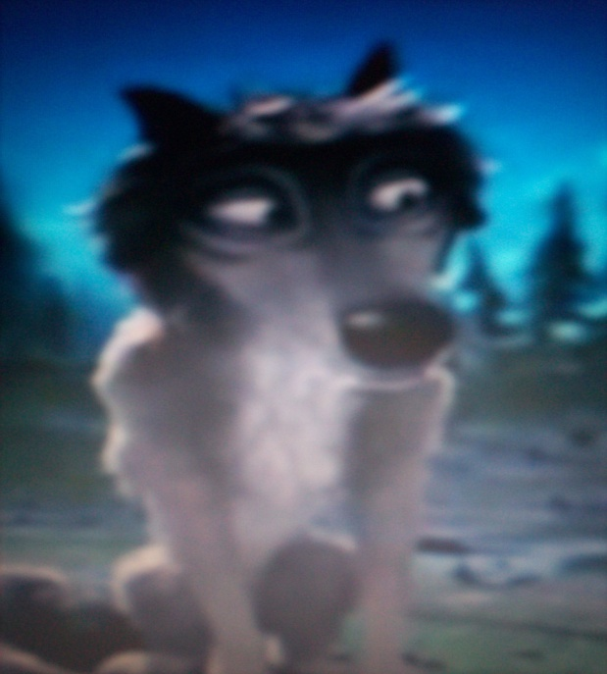 Salty is an Omega wolf. He is good friends with Humphrey, Mooch, and Shakey. He is seen at the beginning of the movie.
Voice Actor: Brian Donovan
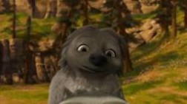 Shakey is also an Omega wolf. He is friends with Humphrey, Mooch, and Salty. He likes the female vegetarian wolves.
Voice Actor: Kevin Sussman
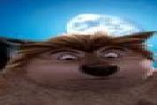 Mooch is an Omega wolf. He is friends with Humphrey, Salty, and Shakey. He is not seen much in the movie.
Voice Actor: Eric Price

