My Little Pony: Friendship is Magic

General Information
In the magical land of Equestria, colorful ponies frolic under the rule of the benevolent Princess Celestia, their ruler and the being in charge of raising the sun in the morning and the moon at night. Twilight Sparkle, the princess’s student, realizes as the Summer Sun Celebration draws near that the event marks the thousandth year since the Mare in the Moon was imprisoned, and that Equestria is in great danger. She tries to alert the princess, but is told with good reason that she’s been studying too much, and sends her and assistant Spike to Ponyville to oversee preparations for the celebration and to make some friends.

While in Ponyville, Twilight meets funny Pinkie Pie, honest Applejack, loyal Rainbow Dash, generous Rarity, and kind Fluttershy. Though she tries to avoid her new acquaintances, Pinkie Pie throws her a party in the library where she is to stay. Early the next morning before sunrise, all of the ponies gather to celebrate, and are surprised to find that princess Celestia is missing and in her place, Nightmare Moon has appeared and has declared that Equestria will forevermore be washed in eternal night.

Twilight sets out with the other ponies to try and find the legendary Elements of Harmony, the only things capable of stopping Nightmare Moon and freeing Princess Celestia. Along their journey, they discover that each of them holds a strong characteristic of one of the elements, which helps them to overcome obstacles and eventually find them. But just as Twilight is trying to unlock them, Nightmare Moon appears, and shatters the elements. The other ponies come running, causing Twilight to realize they have become her friends, and she learns that the true elements were inside of them all along. They trap Nightmare Moon and release Celestia, bringing the dawn.

When the princess appears, she reveals that Nightmare Moon is her little sister, Princess Luna, who was jealous of her sister and angry at the ponies for not appreciating her beautiful night. When Celestia offers her forgiveness, Luna rushes to her and they are all welcomed back in Ponyville. Not wanting to leave her new friends, Twilight asks Celestia to stay and learn more about the magic of friendship, a request the princess grants. What more will Twilight learn while staying with her friends?

Main Characters
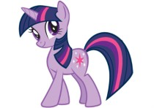
Twilight Sparkle: The main character of the series. Twilight is a very intelligent unicorn, often preferring to research something before diving right into it. At first, she put studying ahead of socializing, but after encouragement from the princess, she’s realized that friends are important to have. Her element is magic.

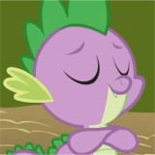
Spike: Twilight’s assistant. He’s a young dragon who is prone to being lazy, sarcastic, and laughing when the others run into misfortune in some cases. However, he is extremely loyal to Twilight and dependable when the need arises. He has developed a crush on Rarity.

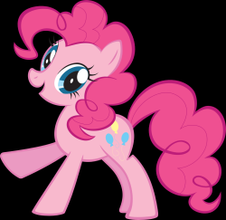
Pinkie Pie: Pinkie is one of the most random ponies you’ll ever meet. She’s very funny and talkative, and she plans some of the best parties in Ponyville. She enjoys bouncing around, singing, and occasionally pulling pranks on her friends (except for Fluttershy!). There is almost never a day when you can’t see her smiling or lauging. Her element is laughter.

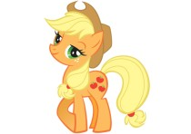
Applejack: A really hardworking pony, who is dependable and very down to earth. She’s very willing to help out anyone, but she has been known to be very stubborn and independent. She comes from a large family who own Sweet Apple Acres, and she loves to harvest the apples with them. Her element is honesty.

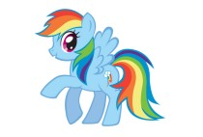
Rainbow Dash: One of the fastest fliers in all of Equestria. She is brave, adventurous, mischievous, and proud. Like other pegasus ponies in Ponyville, she helps change the weather and dreams of one day joining the flying team known as the Wonderbolts. Her element is loyalty.

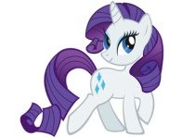
Rarity: Rarity is the stylish pony. There is seldom a day when she doesn’t look her best, and she takes fashion to a whole new level. She owns her own boutique in Ponyville. She acts sophisticated and longs to be the center of attention. Despite this, she is very kind, if not dramatic. Her element is generosity.

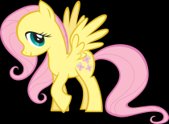
Fluttershy: A very sensitive pony, Fluttershy really does take after her name. She sweet, very calm, and almost always speaks in hushed tones, and isn’t very brave. But she has one of the biggest hearts of any pony, and goes out of her way to care for animals. Her element is kindness.

