Introduction
Ever wonder what life was like in the center of the west? To live out on the golden kissed plains or the mysteries behind those rolling mountains? Or what ever did happen to the west back then? Spirit Stallion of the Cimarron is just that story, said from the stallion's honest point of view to give you even more in depth connection to this heart-warming movie. The story foretells the life struggles of a young buckskin colored Kriger mustang stallion born in the very heart of Western America to preserve his herd's freedom. From the very beginning Spirit was always stubborn and just with others. As he grew, so did his responsibilities within the herd until he walked in his father's hoof beats. An indomitable stallion, rich with the love of his family and they pride they held for him, for Spirit gave the herd a full sense of protection. It seemed as if nothing could possibly get to them or harm then in anyway, But fate had other plans for the stallion.

On a star filled night, his inquisitive and curious nature drew her from his family an into danger that would soon change his life for ever. Spirit may be ambitious and smart but little does he know that mankind is stubborn, and relentless to capture the stallion. In his many dangerous attempts, a Lakota Indian's respect towards Spirit, bloomed him a powerful friendship with the stallion. Who would know this Indian would return upon savior to Spirit. In his perilous journey he will be friend a special few, gain new enemy, possibly a love, and most importantly, respect from the human kind. And would love ever catch up with this majestic stallion?

Would they capture him? Would the humans finally finish building the train to cut across the west and continue their demise upon wildlife? Will the Spirit that can never be broken live up to his name?
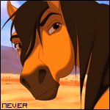

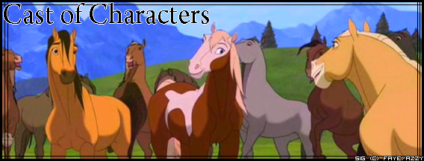

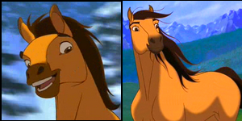
Spirit : The main character in the story. A young Kriger mustang born in the very heart of the west to the palomino mare known as Esperanza. He is of a buckskin color, with the dark brown dorsal stripe included. Since a colt, he was stubborn and always seem to get into trouble, sometimes with out even meaning to. As he grew, Spirit obtained leadership of the Cimarron herd, just like his father before him. As the story continues he proves out to be as wild and uncontainable as his name, evading the men away from his family. He faces dangers, friends and foes on his path to keeping his homeland untouched and preserved from mankind.

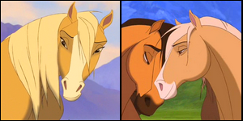
Esperanza : The dam (mother) of the buckskin Spirit, she is the soft golden palomino with the fine even temperament. Her name means Hope in Spanish and this is somewhat her role in the movie, for she cam to Spirit's mind when he needed her to feed his mind again with hopeful thoughts for the future. Not much is known about her except for the unconditional love she has for her son and to strengthen the link between the hero and his homeland.

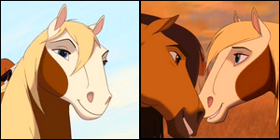
Rain : This is the beautiful paint mare the Spirit falls for in the movie. She may be a passive and quiet mare but she will step down her hoof if need be. Rain (River in France) lives with Little Creek in the Lakota village, she appreciates and trusts him and seems to have always lived there. This said she does it much like,quote from Spirit himself “Like a love struck yearling” which clearly points out the powerful bond the mare and boy have. Together with Little Creek she meets Spirit and quickly falls for him charm.

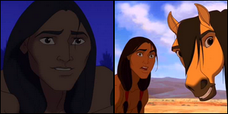
Little Creek : We first see Little Creek, the young Lakota in the US Cavalry camp. He had been captured because they caught him stealing some food from the camp. Even from a distance, Spirit could tell that this boy was different from the other men around them. After Spirit managed to buck The Colonel off him, Little Creek saves the stallion from being killed by the enraged Colonel and together they escape. From there Little Creek took Spirit back to his Lakota village, where Spirit meets his mount and trusted mare, Rain, in hopes of being able to ride the Kiger stallion. After a long while Little Creek understands that Spirit is wild and was always meant to be that way. Finally Spirit trust Little Creek in the end and learns that not all humans are trying to take him away from his homeland.

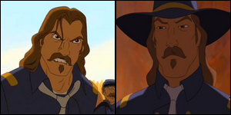
The Colonel : He is the villain of the story and colonel of the US Cavalry camp, whom crosses paths with Spirit various times during the movie. Many sought Spirit as a symbol of freedom, but he only saw spirit as one of the biggest obstacles to pass on his way to conquest the West. Tame the stallion, tame the lands. Thus he is a very ambitious man who fights against Spirit's heart, in the end he bows to defeat, honoring Spirit with his much deserved respect.

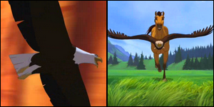
The Eagle : In the movie there is no name given for this American bald eagle whom we see on various times along the movie. All on very emotional and critical circumstances; In the opening sequence, showing the beauty of the American west, racing Spirit as a symbol of how free he feels, and while Spirit longs for his freedom after he's captured and whilst he dreams of returning to his homeland. Its evident that this eagle represents Spirit's freedom, as well as his most favored running companion.

All Images Here have been edited/ re-formatted by
Faye_Garoux and are NOT to be re-distributed without MY
written Consent

All Information here was provided for by
FAYE_LOUP GAROUX
Please do not copy/re-distribute without MY prior knowledge
and I'm warning you I WILL know if you copied and pasted

