The Lady and the Tramp
About the movie
Directed by: Wilfred Jackson, Hamilton Luske & Clyde Geronimi
Produced by: Walt Disney
Written by: Screenplay - Erdman Penner, Ralph Wright, Joe Rinaldi, Don DaGradi
Concept – Joe Grant
Music by: Oliver Wallace
Studio: Walt Disney Pictures
Release date: June 22, 1955
Running time: 75 minutes

Overview
The Lady and the Tramp is the tale of a romance between an upper-class Cocker Spaniel named Lady who enjoys an ordinary life with her owners Jim Dear and Darling and a street dog mutt named Tramp who lives life to the full.
Lady befriends Tramp despite her friends not liking him and how different the two are and this friendship blossoms into love. This classic follows their love and the obstacles they overcome. The Lady and the Tramp is a great love story for all the family.

Character profiles
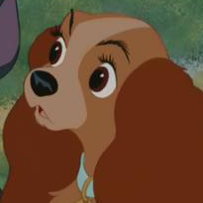
Lady is a purebred Cocker Spaniel who lives with her owners Jim Dear and Darling and their baby. Lady is shown to be pampered but loving and kind. At the end of the movie she becomes mates with Tramp and has puppies

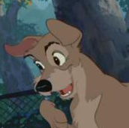
Tramp is a cocky and charming mutt who lives on the streets and he believes in living in the moment. He is friends with the chef at a restaurant called Tony’s and often eats there. Tramp has a talent for picking locks and avoiding dog catchers.
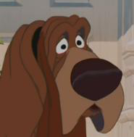
Trusty is a Bloodhound who is one of Lady’s close friends. He used to track down criminals with his grandfather, Old Reliable, until he lost his sense of smell (though he doesn’t know it yet)
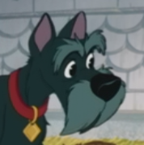
Jock is a Scottish terrier who speaks with a Scottish accent. He lives close to Trusty and Lady. Jock is a show dog who has many trophies.

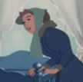
Darling (as she is known to Lady) is the wife of Jim Dear. Darling is portrayed as a mother
figure and a friend to Lady. Darling’s face is shown in the movie, but not clearly.

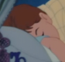

Jim Dear (as he is known to Lady) is the husband of Darling and both a fatherly figure and a friend to Lady. Jim Dear’s face is never shown clearly.

